
MUUGLines
The Manitoba UNIX User Group Newsletter
Volume 37 No. 7, March 2025 Editor: Kevin A.
Next Meeting: March 4th, 2025, 7:30pm In Person and Online
Feature Presentation: Raspberry Pi Sensors By Wyatt Zacharias
Wyatt will present I2C sensors on a Raspberry Pi. While many have come to use the Raspberry Pi simply as a mini linux computer with regular USB peripherals, one of the unique features of the Pi is its 40 GPIO pins which include support for the I2C (inter-integrated circuit) protocol. This low level communication protocol opens a wide array of small sensors available for use with the Pi. Wyatt will demo the basics of connecting I2C sensors to the Pi, and some of the software that can interact with them.
March & April Door Prizes
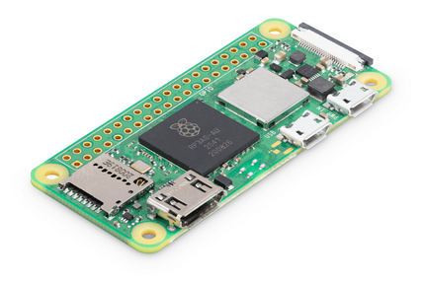
Along with our usual selection of e-books, Wyatt Zacharias has acquired for MUUG two Pi Zero W 2's along with two Pi SD cards for us to give away!

If you show up in person, you will be treated to more beverage choices than we’ve offered in over a decade: coffee, tea, and pop, as well as various chocolates and cookies. And parking is free, copious, safe, and just a handful of feet from the door.
Please stay home if you are sick that day.
To attend via internet, check and refresh the following link after 7:00pm. There is no need to create an account in BBB, nor login. Just enter any name as your screen name and hit join.

https://muug.ca/meet

The latest meeting details are always at:

https://muug.ca/meetings/
Where to Find the Meeting
We are continuing to meet on the first Tuesday of every month.
Fortress Software Inc.
350 Keewatin St – Unit #2



Doors will open at 7:00pm. Meeting starts at 7:30pm.
If driving, enter the lot using the most north-eastern entrance (far right in the top picture) and drive around to the south west corner of the building (see route in map detail). You can use any of the free, ample, and safe parking spots that say “reserved” or “MUUG” in front of units #1 through #4 before entering into unit #2. Look for the sign over the door!
Bus stops #30814 and #30880 (route 77) are only 150 meters away. The last bus leaves for Polo Park at 10:15 pm and for Garden City at 10:31 pm. Logan Ave. bus routes #19, #26, and #27 are a 600 meter (8 minute) walk to the south.
GRUB2 Security Patch Released
A major security patch for GRUB2 has been announced by Daniel Kiper on February 18, addressing multiple boot security vulnerabilities
The most severe issues, some with potential Secure Boot bypass implications, have been assigned CVEs and will require updates from Linux distributions and vendors.
Note that the, full mitigation will also involve an updated shim with the latest SBAT (Secure Boot Advanced Targeting) data. Unlike previous patches, the UEFI revocation list (dbx) will not be used this time.

Key Vulnerabilities Patched
- Heap out-of-bounds writes when parsing JPEG, TAR, and UFS files, which could allow attackers to modify memory and potentially bypass security.
- Integer overflows in multiple filesystem drivers (ReiserFS, SquashFS, UFS, etc.), giving way to more out-of-bounds read and writes.
- Use-after-free in GPG module, which could enable arbitrary code execution.
- Network-based out-of-bounds writes, correctly exploited, by-passes secure boot protection.
- Unrestricted memory dumping, which could expose signatures, salts, etc. from memory.

What You Need to Do?
- Wait for Linux distros to provide the patches in their package repositories.
- Apply all pending GRUB2, shim, and Secure Boot updates as soon as they are available.
- If using Secure Boot, check mokutil(1) for applying SBAT revocations.
Team Fortress 2 Goes Open Source
Team Fortress 2 (TF2) one of Valve’s most iconic games, originally released in 2007, has maintained an active player base for nearly two decades, a testament to the people who stick to the nostalgia.
TF2 was built on Valve’s Source engine, which also powered many well-known games, including Half-Life 2, Counter-Strike: Source, Portal, and Dota 2.

The Source engine was first released in 2004 and was later succeeded by Source 2 in 2015.
While the Source engine itself is not open source, its Software Development Kit (SDK) has long been available to the public, enabling the creation of mods, fan-made games, and various applications.
On February 18th, TF2’s source code was officially made public following an announcement on the game’s website. A commit to Valve’s Source SDK simply stated: “Add Team Fortress 2 SDK”—a change that added over 1 million lines of code across over 5 thousand files.
This development allows the community to modify and rewrite the game as they see fit, potentially leading to a wave of custom content and fan-driven updates.
However, it also suggests that official support for TF2 may be coming to an end, with no further updates to be expected from Valve.
Pot Vs Kettle: OpenAI Accuses DeepSeek Of Stealing Their Data
DeepSeek, a Chinese AI startup, has caused quite the stir in Silicon Valley with the release of its open-source Large Language Model (LLM), DeepSeek-R1.
Despite facing GPU export sanctions against China, DeepSeek managed to develop and release a model that has not only matched OpenAI’s proprietary models, but according to some experts, has surpassed them. The the AI industry is in shambles and Silicon Valley businesses are scrambling to catch up.
Except where otherwise noted, all textual content is licensed under a Creative Commons Attribution-ShareAlike 4.0 International License.

https://creativecommons.org/licenses/by-sa/4.0/
MUUG would like to thank Michael W. Lucas for donating one of his ebooks every month as a door prize. You can view and purchase his tech books here:

https://www.tiltedwindmillpress.com/product-category/tech/
A big thanks to Les.net for providing MUUG with free hosting and all that bandwidth! Les.net (1996) Inc. is a local provider of VoIP, Internet and Data Centre services. Contact sales@les.net by email, or +1 (204) 944-0009 by phone.
Even more impressive is that DeepSeek claims to have built its AI model with a budget of only $6 million—just a fraction of the billions spent by American companies like Meta, Google, Microsoft, and OpenAI.
Yet, DeepSeek-R1 is not only comparable to the best models available today, but it was also released as open-source. This means anyone can inspect, study, and run the model themselves, bypassing the need for subscription services that American companies offer.

And with the stir comes the smell of drama and controversy. OpenAI has accused DeepSeek of using its proprietary data without authorization to build their model.
This claim is ironic, given that OpenAI itself faced backlash when it first launched ChatGPT. In 2023, OpenAI was sued for allegedly harvesting massive amounts of private conversations, copyrighted materials, and other information illegally to train its own models such as ChatGPT.
With OpenAI now accusing DeepSeek of similar misconduct, people are quick to point out the irony: the pot calling the kettle black. If the allegations are true and DeepSeek did use OpenAI’s models, it would unermine their claim of a $6 million price tag for DeepSeek-R1.
Nevertheless, regardless of the allegations, the release of an open-source model that doesn’t rely on expensive top-tier GPUs is still a significant achievement. It’s a step forward in making powerful AI more accessible, and that’s something worth noting.
Taking A Crack At Kindles
Amazon’s Kindle e-readers have been around since 2007, and like any popular gadget, they’ve fostered their own community of power users eager to unlock the full potential of the device—beyond what Amazon offers.
Recently, part of the modding community over at MobileRead has released a new jailbreak called WinterBreak. This jailbreak is supposed to work on all Kindle devices, regardless of their firmware version.
Whether it’s an aversion to being chained, or wanting to use alternative apps, the community is committed to making the Kindle experience more flexible and user-friendly.
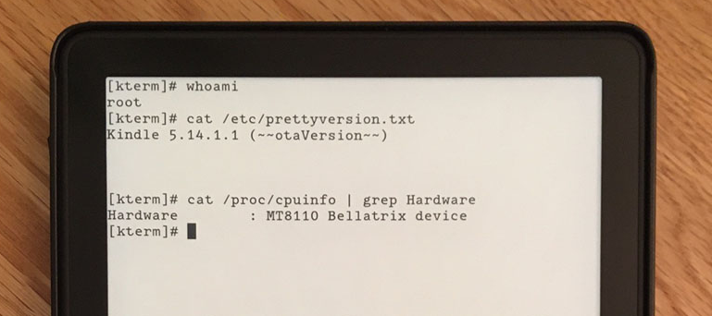

Interestingly, this comes on the heels of Amazon’s announcement that they will be removing the ability to download books and transfer files over USB on Kindle devices.
Starting February 26th, the feature that allowed users to download e-books from Amazon’s website and transfer them via USB will no longer be available. A feature that was initially introduced when Wi-Fi wasn’t as ubiquitous and Kindles lacked the wireless capabilities they have today. It was a convenient way to download and transfer books to your device.
Amazon claims the change is to combat piracy and the transfer of unauthorized e-books. But that’s not all it affects. Without this feature, Amazon essentially tightens its grip on users’ digital libraries, putting them at the mercy of the company.
While it’s rare, books have occasionally been removed from Amazon’s online store and remotely deleted from Kindles, or replaced with new editions that overwrite the original content. It’s a stark reminder that, in reality, you don’t fully own the books you’ve purchased—or even the device in your hands.
As with all forms of jailbreaking, it’s an ongoing arms race between users seeking more control and the company working to maintain its restrictions. For now, though, Kindle owners still have ways to use their devices for more than what Amazon originally intended.
xkcd/3052: Archive Request


