
MUUGLines

Help us promote this month’s meeting, by promoting this poster on your workplace bulletin board or other suitable public message board:

https://muug.ca/meetings/MUUGmeeting.pdf
The Manitoba UNIX User Group Newsletter

Volume 38 No. 4, December 2025 Editor: Bradford C. Vokey
Next Meeting: December 2nd, 2025
*** Pot-Luck Meeting! ***
As 2025 draws to a close, MUUG will continue it’s tradition of turning the December meeting into more of a social event.
This will be a pot-luck snack event

Members are encouraged to bring their own food to sample and share with others. Feel free to bring your own special drink as well – just remember that we don’t have a liquor license!
Bring your favorite gadget

Bring your favourite gadget! We will have the usual (brief) round-table session, a gadget show & tell, and then have some time for mingling, eating, and drinking.
We will also attempt to simulcast the live round-table and any short show & tell story’s over Big Blue Button for those that can’t attend in person: https://muug.ca/meet
The latest meeting details are always at:
https://muug.ca/meetings/

Where to Find the Meeting:

Skullspace, 374 Donald St - Suite #200
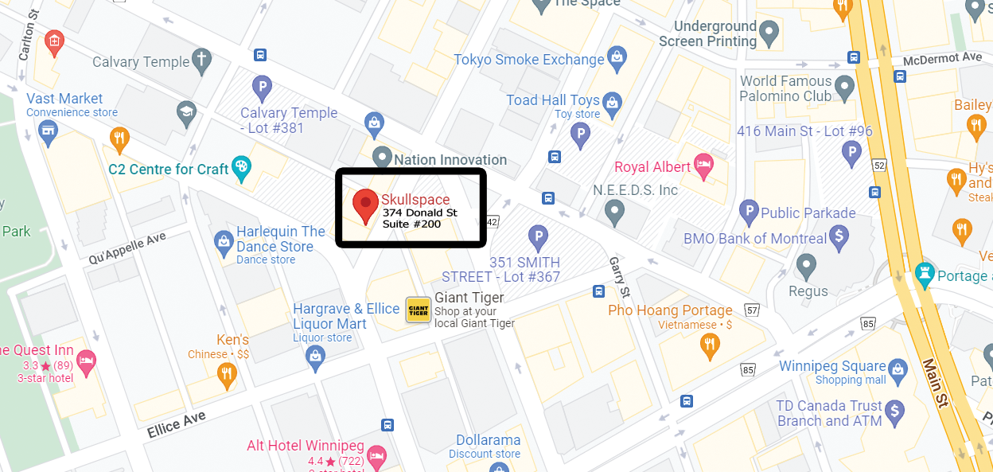
Kevin Abedi has graciously arranged for us to use the Skullspace location at 374 Donald St., for our December meeting. We will be in room 200.
Please note that this location is not mobility accessible. There are 3 flights of stairs and it is 1.5 stories up.
There is no Winnipeg Jets home game on December 2nd so downtown street parking should be plentiful and easy to find.
One of the best blocks for street parking is Notre Dame after Hargrave. There is also lots of commercial parking lots in the area including right behind the Skullspace building.
Wyatt Zacharias
The F8 bus route has a southbound stop (#10667) on the same block of Donald in front of the Yellow Dog Tavern. It’s also reasonable to walk from stops on Graham, Portage, Smith, King and Notre Dame.
Doors will be open starting at 7:15 pm with the meeting starting at 7:30 pm. After 7:45 pm the doors may be locked so you will need to call the Skullspace number (204-480-4092) for someone to come down and let you in.
Meet Your New Board
The MUUG Board for the 2025-2026 year was elected by acclamation at the November general meeting.

Your MUUG board now consists of the following 7 members:
- Kevin Abedi
- Trevor Cordes
- Gilbert Detillieux
- Kevin McGregor
- Tyhr Trubiak
- Brad Vokey
- Wyatt Zacharias
A big thank you to all the nominees who let their names stand for election and an even bigger thank you to Alberto Abrao for his energetic contributions to the board over the last 5 years.
Board Positions
Your new board held their first board meeting on November 11th, and for the 11th year in a row they elected the same executive officers:
President: Wyatt Zacharias
Vice-President: Trevor Cordes
Secretary: Gilbert Detillieux
Treasurer: Brad Vokey

11 years
as our
BDFL!
We also appointed the following unofficial officers:
Stand-In Social Media Ninja: Brad Vokey
Door Prize Don: Trevor Cordes
Banking Committee: Brad Vokey, Gilbert Detillieux, Kevin McGregor, and Wyatt Zacharias.
Server Committee: Trevor Cordes, Gilbert Detillieux, and Wyatt Zacharias.
The new board looks forward to serving you over the next year. If you have any questions or requests, feel free to send an email to <board@muug.ca>.
Except where otherwise noted, all textual content is licensed under a Creative Commons Attribution-ShareAlike 4.0 International License.

https://creativecommons.org/licenses/by-sa/4.0/
Food Bank Donations Requested

As in previous years, we are combining our pot luck event with a food drive for Harvest Manitoba.
Over 108,000 Manitobans rely on Harvest Manitoba every month for food and hope. This holiday season, your donation can help ensure no one goes hungry.
Any member who donates at least $1 or brings at least 1 food item will be given an entry into the door prize!
Just like last year, any cash donation made to Harvest Manitoba at this event will be matched dollar for dollar by Bradford Vokey (up to a total $500 limit)!
Last year MUUG members donated $128 (an appropriate power of 2)which Brad had to match for a total donation of $256 to Harvest Manitoba.
Let’s all chip in to make Brad donate more this year!
Top 10 Most-Wanted Food Items
1. Canned Fruit | 6. Pasta Sauce
2. Canned Soup/Stew | 7. Rice
3. Canned Tuna | 8. Peanut Butter
4. Canned Vegetables | 9. Baby Formula/Food
5. Pasta | 10. Instant Oatmeal
Any Comments on this Newsletter?
A donation may be required...

https://xkcd.com/3113
December Door Prizes:
Along with our usual selection of e-books and Linux Magazine, we will also give away the physical paper book:


97 Things Every Programmer Should Know: Collective Wisdom from the Experts
By: Kevlin Henney
Publisher: O’Reilly Media
Release Date: March 23, 2010
Pages: 255
Tap into the wisdom of experts to learn what every programmer should know, no matter what language you use. With the 97 short and extremely useful tips for programmers in this book, you’ll expand your skills by adopting new approaches to old problems, learning appropriate best practices, and honing your craft through sound advice.
With contributions from some of the most experienced and respected practitioners in the industry – including Michael Feathers, Pete Goodliffe, Diomidis Spinellis, Cay Horstmann, Verity Stob, and many more - this book contains practical knowledge and principles that you can apply to all kinds of projects.
A few of the 97 things you should know:
- “Code in the Language of the Domain” by Dan North
- “Write Tests for People” by Gerard Meszaros
- “Convenience Is Not an -ility” by Gregor Hohpe
- “Know Your IDE” by Heinz Kabutz
- “A Message to the Future” by Linda Rising
- “The Boy Scout Rule” by Robert C. Martin (Uncle Bob)
- “Beware the Share” by Udi Dahan
FFmpeg to Google: Fund Us or Stop Sending Bugs
A lively discussion about open source, security, and who pays the bills has erupted on Twitter.
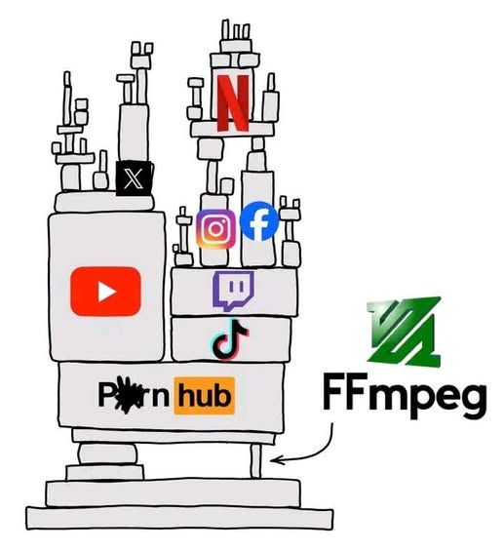
A lively debate on Twitter began between Dan Lorenc, CEO and co-founder of Chainguard, the software supply chain security company, the FFmpeg project, Google, and security researchers over security disclosures and the responsibilities of large tech companies in open-source software. The latest episode was sparked after a Google AI agent found an especially obscure bug in Ffmpeg.
How obscure? This “medium impact issue in ffmpeg,” which the FFmpeg developers did patch, is “an issue with decoding LucasArts Smush codec, specifically the first 10-20 frames of Rebel Assault 2, a game from 1995.”
MUUG would like to thank Michael W. Lucas for donating one of his ebooks every month as a door prize. You can view and purchase his tech books here:

https://www.tiltedwindmillpress.com/product-category/tech/
A big thanks to Les.net for providing MUUG with free hosting and all that bandwidth! Les.net (1996) Inc. is a local provider of VoIP, Internet and Data Centre services. Contact sales@les.net by email, or +1 (204) 944-0009 by phone.
Thanks to Linux Mag for providing MUUG a half price magazine subscription for our door prizes.
Linux Magazine is your guide to the world of Linux and open source. Each monthly issue includes advanced technical information you won’t find anywhere else including tutorials, in-depth articles on trending topics, troubleshooting and optimization tips, and more! Subscribe to their free newsletters and get news and articles in your inbox.

https://www.linux-magazine.com/
Many in the FFmpeg community argue, with reason, that it is unreasonable for a trillion-dollar corporation like Google, which heavily relies on FFmpeg in its products, to shift the workload of fixing vulnerabilities to unpaid volunteers. They believe Google should either provide patches with vulnerability reports or directly support the project’s maintenance.
Read the full story here:

https://thenewstack.io/ffmpeg-to-google-fund-us-or-stop-sending-bugs/
MUUG Annual Financial Statements
By Bradford C. Vokey, MUUG treasurer
MUUG membership increased by 1 member last year! We now have a total of 38 paying members.
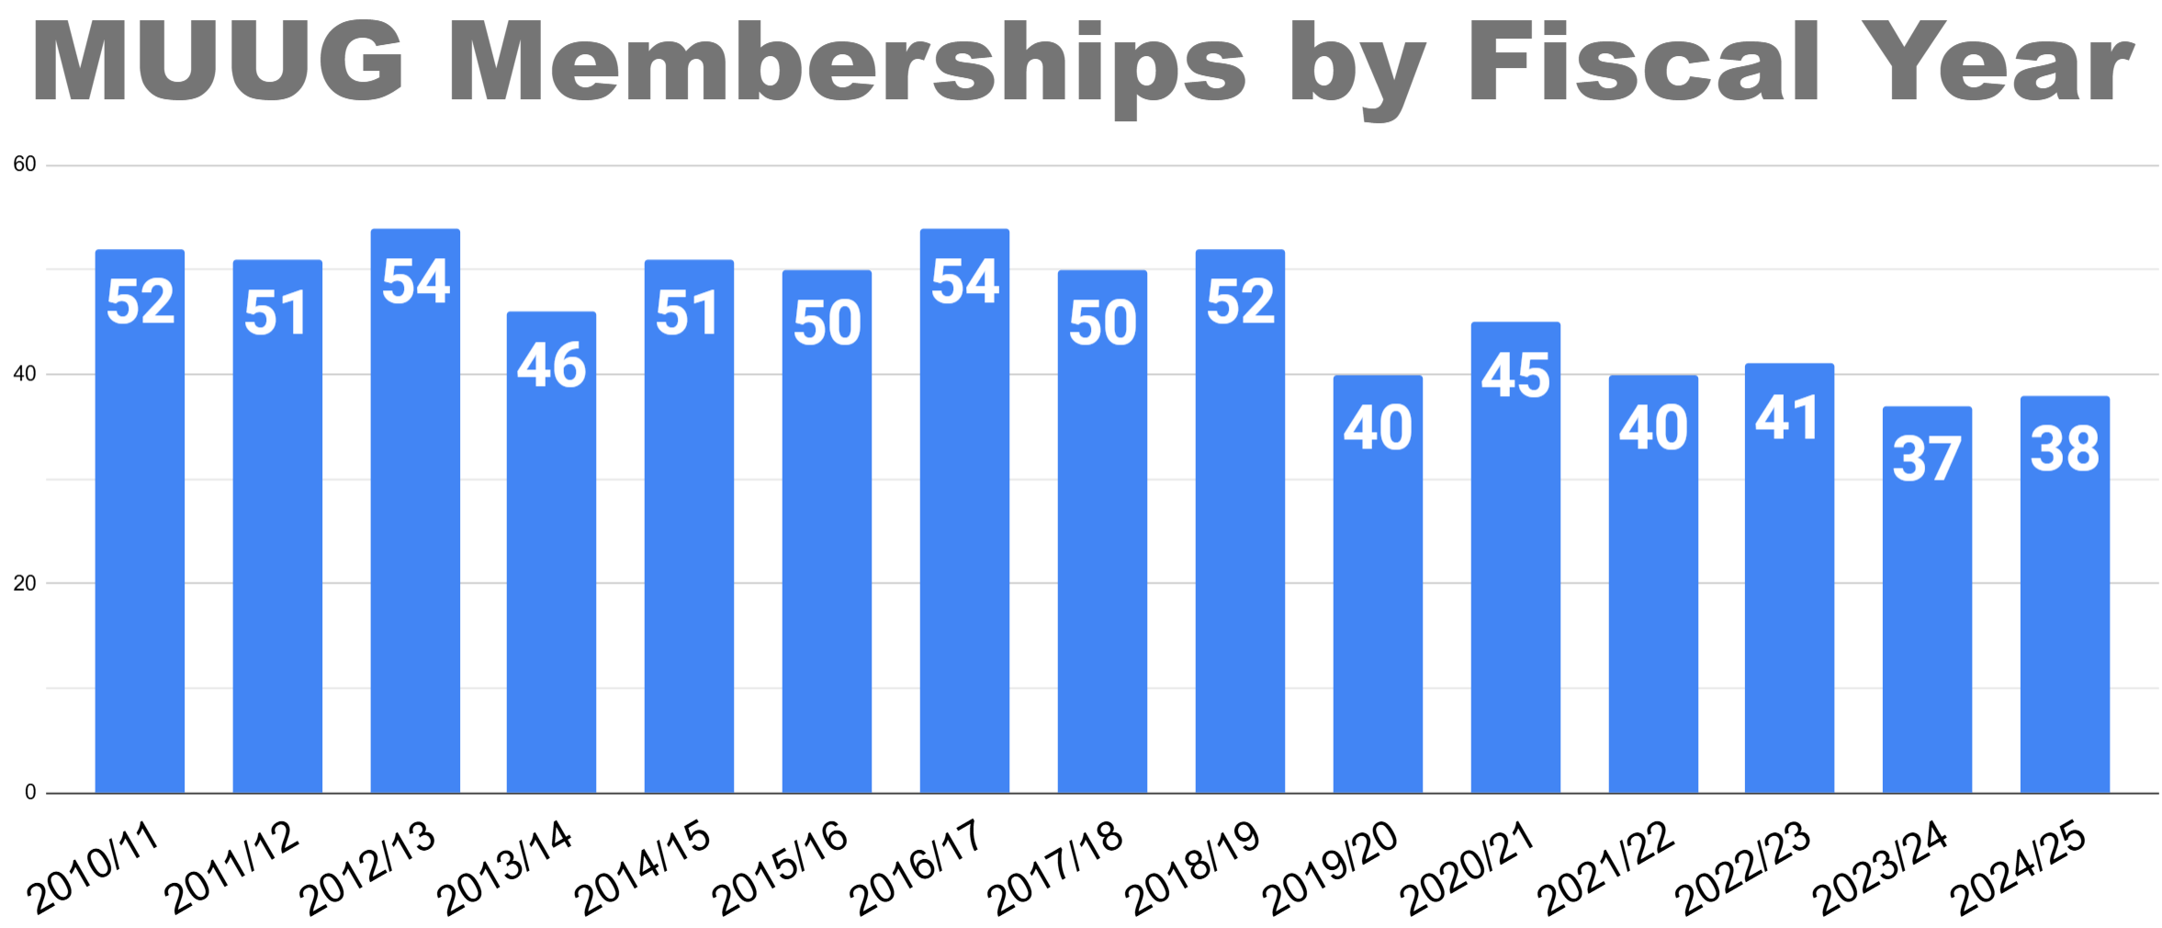
Thanks to all our fabulous members who continue to renew their memberships.
If your MUUG membership has lapsed, please help support us by renewing today! Payment can be made via e-transfer, credit card, or PayPal here:
https://muug.ca/about.php#payment

We ended the year with a $143.10 deficit. Your board is continuing to slowly and carefully use our built up surplus to help serve the *nix and open source community here in Manitoba.
As per our bylaws (11.(h)) “The books and records of MUUG may be inspected by any member at the Annual Meeting or at any time upon not less than fourteen days notice in writing to the Executive.”
52-year-old data tape could contain only known copy of UNIX V4
It might have the first-ever version of UNIX written in C
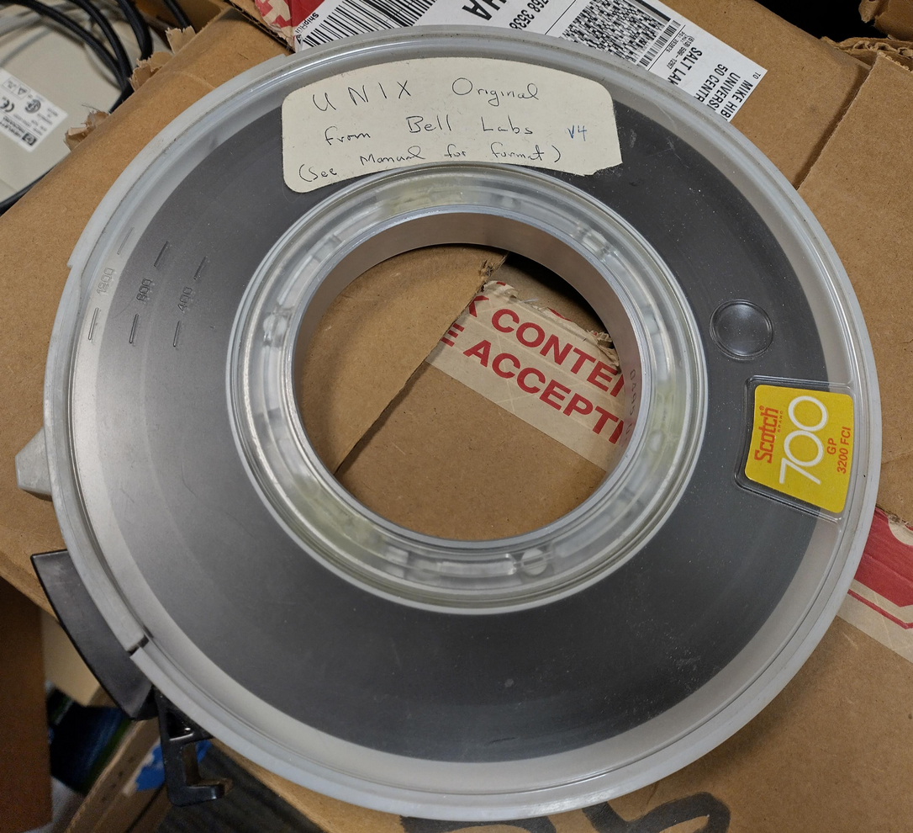
A tape-based piece of unique Unix history may have been lying quietly in storage at the University of Utah for 50+ years. The question is whether researchers will be able to take this piece of middle-aged media and rewind it back to the 1970s to get the data off.
The news was posted to Mastodon by Professor Robert Ricci of the University of Utah’s Kahlert School of Computing:
“While cleaning a storage room, our staff found this tape containing #UNIX v4 from Bell Labs, circa 1973.”
“Apparently no other complete copies are known to exist: https://gunkies.org/wiki/UNIX_Fourth_Edition.”
“We have arranged to deliver it to the Computer History Museum.”

https://www.theregister.com/2025/11/07/unix_fourth_edition_tape_rediscovered/
Programming’s Greatest Mistakes
A great way to waste 51 minutes laughing at us programmers!
Most of the time when we make mistakes in our code, a message gets displayed wrong or an invoice doesn’t get sent. But sometimes when people make mistakes in code, things literally explode, or bankrupt companies, or make web development a living hell for millions of programmers for years to come.
Watch the funny presentation from the GOTO Amsterdam 2023 conference, where Mark Rendle gives us a tour through some of the worst mistakes in the history of programming:

https://youtu.be/Y9clBHENy4Q
Our Corporate Sponsors:

